MODULE 1
- CODE SNIPPETS-LOOP INVARIANTS
- TIME COMPLEXITY
- RECURRENCE RELATION
- ITERATION METHOD
- MASTER METHOD
- SUBSTITUTION METHOD
- RECURSIVE TREE METHOD

MODULE 2
ARRAY AND IT TYPES
ONE DIMENSIONAL ARRAY
TWO DIMWNSIONAL ARRAY

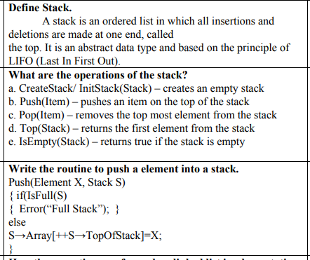

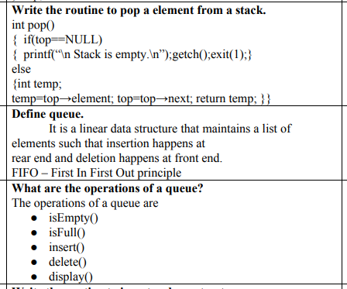
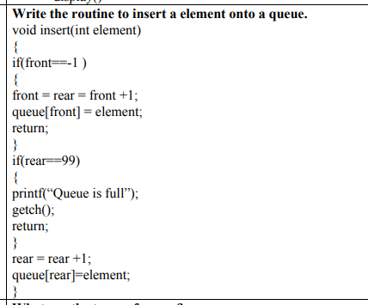
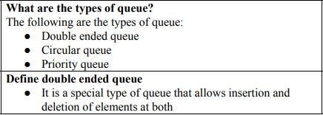
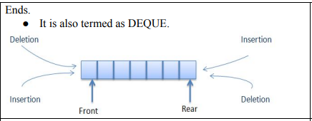
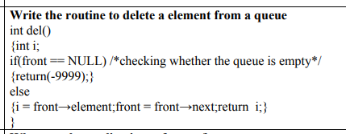

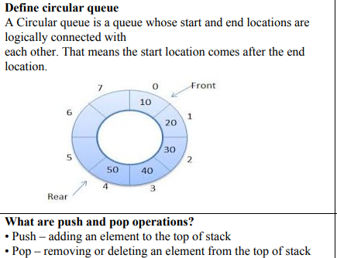
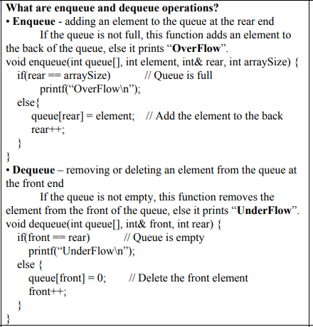
APPLICATIONS OF STACK
- CONVERSION OF INFIX TO PREFIX
- CONVERSION OF INFIX TO POSTFIX
- TOWERS OF HANOI PROBLEM

SEARCHING
- PSEUDOCODE FOR LINEAR SEARCH – TIME COMPLEXITY
- PSEUDOCODE FOR BINARY SEARCH – TIME COMPLEXITY

SORTING
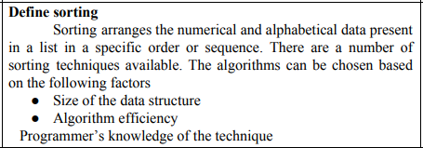
- PSEUDOCODE FOR INSERTION SORT – TIME COMPLEXITY
- PSEUDOCODE FOR BUBBLE SORT – TIME COMPLEXITY
- PSEUDOCODE FOR SELECTION SORT – TIME COMPLEXITY

